1. Details of the Invention:
a. Title of the invention:
AI Facial Recognition for Proxy Prevention
b. Field of the invention [Broader subject area of the invention] Artificial Intelligence & Computer Vision
- Stage of development [please tick]:
  - Idea only
  - Proof of concept
  - Prototype
  - Tested
  - In use/ deployed
d. Is the invention based on |  Product |  | Process/Method |  | Composition | Other
e. What is/are the Novel/New aspects of the invention? What is the inventive step? [What problems are being solved by the invention]
Real-time facial authentication integrated with continuous monitoring
Unlike prior systems that verify identity only at entry, this invention performs continuous face verification throughout the entire examination period, preventing mid-exam impersonation.
Automated AI-driven proxy detection with immediate alerts
The system intelligently detects mismatched faces, absent faces, or face-hiding attempts and instantly notifies invigilators, forming a novel real-time intervention capability.
Multi-camera, hall-wide identity consistency tracking
The invention introduces synchronized computer-vision tracking across multiple cameras, ensuring that each candidate remains consistently identified regardless of seating angle or movement.
Integration of facial recognition with exam-specific databases
The system uniquely links facial data with candidate registration details and seating plans, enabling automated, exam-oriented identity validation—something not present in conventional biometric systems.
AI-based behaviour and liveness verification
Continuous liveness checks and behavioural analysis (e.g., covering face, swapping seats) make impersonation impossible, solving critical gaps in existing CCTV and biometric methods.
f. Is there any prior art for this invention: [Has the problem been solved/ Is the problem being solved in any other manner by others? Limitations and drawbacks of prior art]

US20190345678A1:
Describes facial recognition for classroom attendance using CNN-based matching. Limited to entry-time verification only; lacks continuous monitoring, multi-camera identity tracking, real-time alerts, liveness detection, and exam-specific proxy prevention workflows.

WO2021132450A1:
Focuses on biometric check-in kiosks for examination centers. Performs only pre-exam identity authentication; missing continuous in-hall monitoring, face-hiding/seat-swap detection, and active behavioural analysis.

US20210101234A1:
Covers webcam-based online proctoring with gaze/face-presence checks for remote exams. Designed only for single-user online settings; no multi-candidate tracking, no seat-map integration, no identity-to-database matching, and not applicable to physical exam halls.

EP3456789A1:
Relates to AI video-surveillance analytics for general crowd monitoring. Not examination-specific and does not include candidate ID matching, liveness verification, proxy detection logic, or exam workflow integration.

CN110987654A:
Describes facial biometric access control for building entry/exit. Provides one-time authentication only; no continuous identity verification, no behaviour analysis, and no multi-camera tracking inside exam halls.

US10548723B2:
Biometric identity verification system for secure facilities. Limited to access control points; lacks continuous monitoring, real-time alerting, and impersonation detection during ongoing activities such as exams.

WO2021189999A1:
AI-assisted cheating detection (eye movement/phone usage) for online exams. Does not address identity mismatch, proxy prevention, seat-position validation, or live cross-checking with pre-registered candidate data.

US11270105B1:
Extraction and analysis of information from video for text/symbol detection. No face recognition, no multi-person identity consistency tracking, and no examination-oriented security application.

JP2020102564A:
General crowd-behavior monitoring system. Lacks identity verification, candidate matching, seat-mapping, and impersonation detection methods needed for secure exam environments.

KR20210034567A:
Face authentication terminal for school entry. No continuous verification, no behaviour analysis, and no detection of in-hall proxy attempts or identity swaps.

- Provide a general overview of your invention, including specific keywords and phrases pertaining to the invention: [Briefly provide the basic understanding of the invention and also point out specific keywords.]

The present invention relates to an AI-driven examination security system designed to eliminate proxy candidates and ensure real-time identity verification inside physical examination halls. The system utilizes multi-camera video input, deep-learning-based facial recognition, liveness/anti-spoofing detection, and continuous behavioural monitoring to verify that the same registered candidate remains seated throughout the exam. The invention automatically matches live facial data with the pre-registered candidate database and seat-map records, detects impersonation attempts, identifies face-hiding or seat-swapping behaviour, and generates immediate alerts to invigilators through a centralized dashboard. The invention enhances exam integrity by providing full-duration, automated, non-intrusive identity consistency tracking along with secure audit logs and evidence reports.

Specific Keywords and Phrases Pertaining to the Invention
- AI-based Examination Monitoring
- Proxy Prevention System
- Real-Time Identity Verification
- Facial Recognition
- Liveness Detection
- Multi-Camera Fusion
- Continuous Monitoring
- Behaviour Analysis
- Candidate Database Integration
- Automated Alert System
- Seat-Map Identity Matching
- Secure Audit Logs
- Deep Learning / Computer Vision
- Identity Consistency Tracking
- Examination Integrity System

- Describe how the invention is more beneficial or feasible over the prior art. [What are the advantages/improvements of the invention as compared to solutions provided by others]

Continuous, Full-Duration Identity Verification
Prior systems verify identity only once at the entry gate.
The invention performs continuous real-time facial verification throughout the entire exam, preventing mid-exam impersonation — a major limitation in earlier technologies.

Automated Proxy Detection With Real-Time Alerts
Existing CCTV or biometric systems do not detect proxy candidates automatically.
The invention provides instant alerts for identity mismatch, face hiding, seat swapping, or unrecognized individuals, enabling immediate corrective action.

Multi-Camera Identity Consistency Across the Hall
Traditional systems operate at a single point of capture.
The invention integrates and synchronizes multiple camera streams, ensuring accurate face tracking from different angles and preventing candidates from avoiding detection.

Direct Integration With Candidate Database and Seating Plan
Prior art does not combine live video analysis with candidate registration records.
The invention uniquely performs live face-to-database matching and seat-map verification, enabling accurate, automated identity validation for each candidate.

Reduction of Human Error and Enhanced Security
Manual invigilation is highly prone to oversight and manipulation.
The invention automates identification, behavioural monitoring, and alert generation, resulting in a more reliable, scalable, and tamper-resistant examination environment.

i.Provide a detailed explanation of your invention: [Specifically describe all the element and components of the invention. Also describe how all the elements and components work together to form the invention. For more clarity and understanding, respective examples, diagrams, flowcharts, etc. may be provided]

Candidate Enrollment and Database Module
This module collects and stores all pre-exam identity data.

Components:
Candidate photograph capture
  - Candidate personal and examination details
  - Seating plan and hall allocation
  - Secure, encrypted identity database

Function:
Before the examination begins, each candidate’s facial image and identity information are registered in the system. This data forms the basis for real-time matching during the exam.

Multi-Camera Capture System
This component captures continuous video streams of all candidates in the examination hall.

Components:
  - Multiple CCTV/AI cameras positioned across the hall
  - Network video streaming unit
  - Camera synchronization controller

Function:
All cameras simultaneously record video of the hall from different angles. This ensures that each candidate’s face remains visible and trackable during the exam.

AI Face Processing and Verification Module
This module performs real-time biometric analysis on incoming video frames.

Components:
  - Face detection algorithm
  - Facial recognition engine
  - Liveness and anti-spoofing detector
  - Face embedding generator

Function:
The system determines whether:
- The detected face is real (not a photo/video/mask).
- The face matches the registered candidate profile.
- The same verified face remains present throughout the exam.

Behavioural and Consistency Analysis Module
This module ensures that the candidate’s identity remains consistent and that no suspicious activity occurs.

Components:
  - Multi-object tracking algorithms
  - Head/face orientation analysis
  - Seat-position verification
  - Behaviour monitoring engine

Function:
This module detects:
  - Face hiding or obstruction
  - Seat swapping
  - Temporary absence from seat
  - Appearance of an unknown face
  - Multiple faces appearing at a single seat

Identity Matching and Verification Module
This component compares real-time face embeddings with the registered database.

Components:
  - Face embedding comparator
  - Seating plan validator
  - Identity confidence scoring engine
  - Decision system

Function:
If the system detects a mismatch, unknown face, or any identity inconsistency, it triggers a real-time alert for invigilators.

Real-Time Alert and Notification System
This system provides immediate warnings when abnormal or prohibited behaviour occurs.

Components:
  - Red alert (proxy/mismatch)
  - Yellow alert (face hiding or abnormal movement)
  - Blue alert (absence from seat)
  - Notification delivery engine

Function:
Alerts are displayed instantly on the invigilator’s dashboard and can also be sent via SMS, email, or mobile notifications.

Invigilator Dashboard

A web-based user interface for real-time examination monitoring.

Components:
  - Live camera feed viewer
  - Seat-map with identity status indicators
  - Alert summary panel
  - Candidate verification logs

Function:
The dashboard allows invigilators to monitor all candidates, track identity verification, and respond to alerts promptly.

Secure Evidence and Audit Module
This system records tamper-proof evidence for security and review.

Components:
  - Timestamped event logs
  - Face comparison snapshots
  - Short video clips of alert events
  - Exportable reports (JSON, CSV, SQL, MP4)
  - Encrypted, access-controlled storage

Function:
All verification activities and alerts are stored as official evidence for future review or disciplinary action.

System Architecture Layer
Back-end processing and system-level integration components.

Components:
  - Cloud or edge GPU processors
  - API gateway
  - Load balancer
  - Security layer (RBAC, encryption, privacy management)

Function:
Ensures fast processing, secure data handling, system scalability, and integration with institutional platforms.

End-to-End Operational Flow
- Candidates are enrolled and assigned seats.
- Multi-camera system captures live examination footage.
- AI detects and verifies each candidate’s face continuously.
- Liveness and behavioural checks run simultaneously.
- Any identity mismatch or suspicious activity triggers alerts.
- Invigilators monitor live alerts via dashboard.
- All activities are logged and stored as evidence.

8. A complete verification report is generated post-exam.

11. Example Scenario
If a proxy candidate attempts to take an exam, the system instantly detects a face mismatch and triggers a red alert. Invigilators are notified immediately, preventing impersonation. The event is stored as evidence with images and video clips.
j.Provide Drawings, if any. [Please note: Drawings need to be provided in 2-dimentional line drawing format, with numerical labeling. We request you to provide the descriptive of numerical labeling below the drawings.]

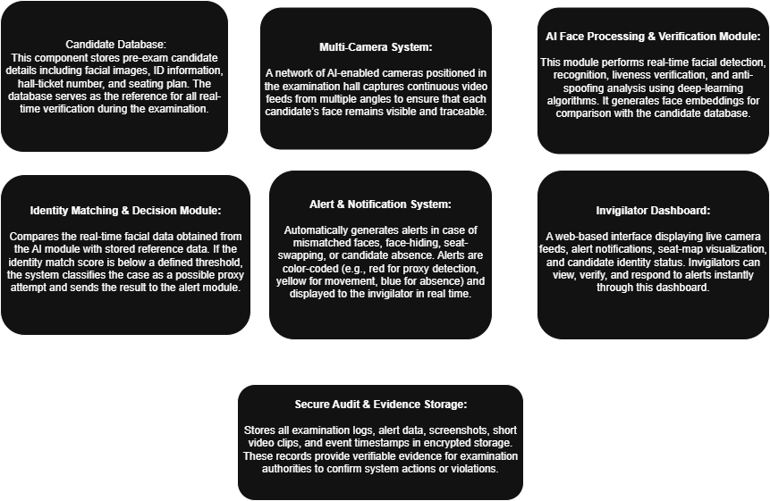

2. Disclosure
a. Has the invention ever been shown or used in public? | Yes | No
If yes, Where | When
b. Was any Confidentiality Agreement Signed regarding  the invention? | Yes | No
c. Has this invention been publicly disclosed (e.g., paper presentation)?  If yes, provide details on title of publication, or presented, Date of disclosure, Conference /Journal  (Attach copies or drafts if available) | Yes | No
3. Foreign Patent Protection
a. Do you intend to pursue International Patent protection | Yes | No
If yes, list the countries in which you want to protect your invention: [Leave blank if unsure]

- Funding & Sponsorship
  - Was this invention developed with external funding: No
  - Funding Agency /Sponsor: N A
  - Grant or Contract number: N A
  - Principal investigator (PI): N A
  - Are there any third -party obligations (e.g. collaborations, industry partners (if yes, provide details):No
- Commercial potential:
  - Potential applications / Industries: The invention can be applied in educational institutions, competitive exam centers, and any industry requiring secure, real-time identity verification to prevent proxy or impersonation.
  - Known Competing technologies: Known competing technologies include basic biometric entry systems, manual ID verification, CCTV surveillance, and online proctoring tools that lack continuous real-time identity tracking.

3. Companies that may be interested in licensing this technology: Educational boards, competitive exam authorities, EdTech assessment companies, and AI proctoring solution providers would be potential licensors for this technology.
6. Inventorship declaration:
I/ we declare that the information provided in this form is accurate and complete to the best of my/our knowledge. I/ we agree to assign rights in this invention to Sona college of Technology, in accordance with institutional policy.
Inventor Signature(s) [If there are more than two inventors enter the details below]:
 |  | Inventor 1 | Inventor 2
 | a. Full Name
 | b. Designation &Department
 | c. Signature
 | d. Date

Authorized Person: Name: Designation: Signature:
Date:

Office use only:

Disclosure number
Date received
Next steps

